Joint Project Design Doc

**Part I**

My game is a basic 2D game, where you have to reach your goal to complete the game. You use standard arrow keys to move and space to attack. It is very easy to handle the controls of the game as there are not many keys to be pressed. (Figure 1)

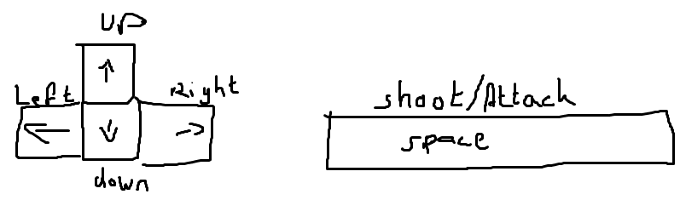

*Figure 1*

Each enemy has a health bar, and it depends on your damage when they will die.

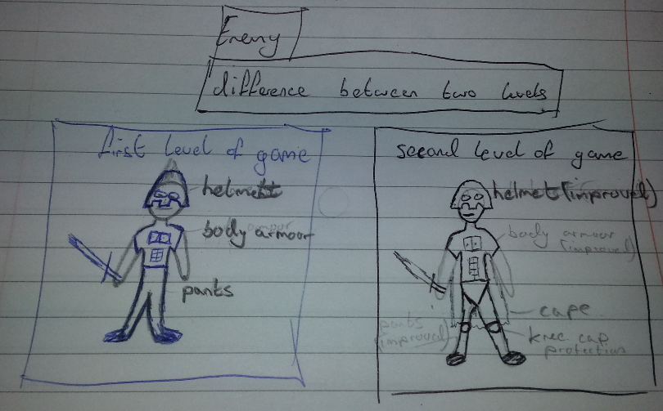It is a slow pace game at level one, but gets harder as you complete each level and go to the next. First type of enemies get harder to kill as they acquire more body armour but at the same time get slower so the game is more balanced. This enemy is moving constantly into your direction or basically just follows you (Figure 2). He is slower than you but needs to be hit plenty of times to be killed. When he gets near you, he will attack and you will lose certain amount of health.

*Figure 2*

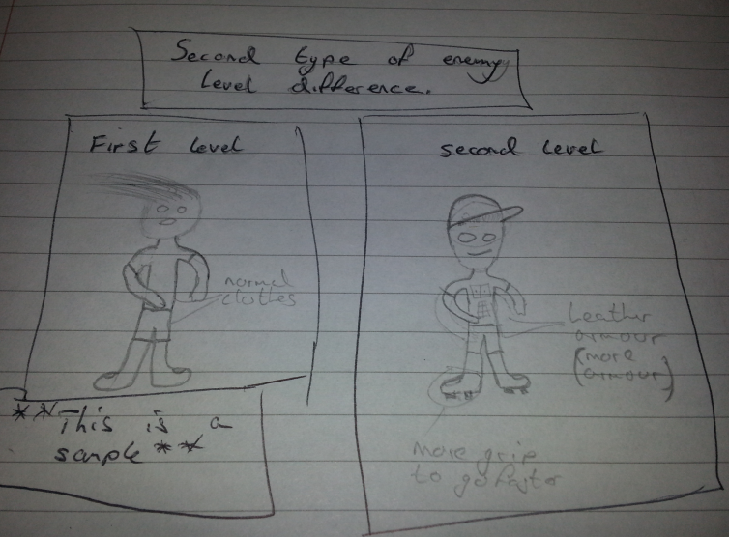The second type of the enemy is fast and is spawned when the first enemy is killed. This way you will not have to fight against two enemies at once and let you focus on one task at a time, the trick is that you need to play by their style of speed and strength. As the game progresses this enemy is getting faster but gets more armour so the speed basically stays the same to once again have the game as balanced as possible. This enemy is faster than you and requires to be hit twice, but remember you have one shot at once so you need to stay moving. This enemy once again, will hurt you as he will get close enough. (Figure 3)

*Figure 3*

There are plenty of power ups in the game which can improve your game.

* Health potion, this power up regenerates your health to max.
* Extra life, this power up gives you extra life.
* Speed boost, this makes you go faster (useful for enemy type 2).
* More damage, this gives you more power on your shot.
* Invincibility, when you acquire this power up it will make you in killable for short period of time.
* You play the game by killing enemies which will try to kill you.
* By pressing the space button you will be able to fire your gun.
* Enemies kill you by walking up and attacking.
* You need to kill them before they kill you to advance to the next level of the game.
* You need to kill the boss in the final round to complete the game.

**Maps**

There will be different maps involved in the game which change as you complete one level and go into the next one. Each map will have different position for the door where the enemy come from and some maps will have different types of enemy which will spawn anywhere on the map. The third enemy will spawn from a grave if he senses your presence in his radius. These spawns will be marked with a cross.

***Little Game Description***

You are going to be walking with your character which needs to kill enemies to advance further in the game. There will be levels in the game which has a boss round in the final level which you need to kill to complete the game (maybe when the boss is killed, the game will increase in difficulty bringing you back to the starting level and repeating the process). When you progress further into the game, the game will spawn different enemies “The Zombies”.

***Game Genre***

In my opinion the best game genre is to give my game is Action, 2D, Platformer and Fantasy. I would not have a clue to what I should compare my game with as I have not played such type game. It can be compared with the Demo projects but with level as the game progression and not game speeding up.

***Goals***

The main goal of the game is to kill a boss which hides himself in the last level of the game. You need to kill all enemies in each level to advance further and get closer to the final round. When all enemies are killed you need to enter the door which the enemies come out from. The player loses if he fails to kill the boss by losing all his lives.

***Player***

The player moves up, down, left and right with the standard arrow keys. He can fire a gun by pressing space. The player can also pick up power ups which give him an advantage over the enemies and make the game a bit easier.

***Enemy***

There are two types of enemies.

Each enemy will drop ammo for your gun.

* The first type is slower than the player but is hard to kill due to heavy armour. This enemy will follow the player. It also gets tougher to kill but slower as the game progresses level.
* Second enemy will be faster than the player. It moves very fast in one direction for few seconds and stops to take a breather. It will then check your position on the map and decide where to go next in the shortest route possible.
* Third enemy, “The Zombie” will move slowly. When it will hit you it will do over time damage and die itself. It will then become a cross which will respawn a zombie again when you walk into the radius.

**Game Progression**

The biggest thing that will keep the player involved in the game is to see the boss in the last round. The first level will be easy to show the player that there is more to the game than just a single map same enemies but just faster. I will involve new enemies such as “The Zombies” and the boss to keep the player going as far as he can. There are no points in this game but the ammo will need to be collected when an enemy is killed. The game can be saved and played from the same spot you left last. This feature is very useful and will encourage the player to actually try and finish the game.